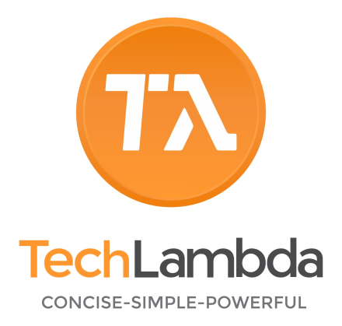

Mastering Cloud Penetration Testing (MCPT) — Course Content

Module 1 – Introduction to Cloud Penetration Testing
- Differences between traditional and cloud pentesting
- Legal considerations & scope agreements
- Understanding the shared responsibility model

Module 2 – Cloud Computing Fundamentals
- Cloud service models: IaaS, PaaS, SaaS
- Cloud deployment models: public, private, hybrid, multi-cloud
- Common cloud architecture components

Module 3 – Cloud Threat Landscape
- Common attack vectors in cloud environments
- OWASP Cloud Top 10
- Cloud-specific vulnerabilities and misconfigurations

Module 4 – Cloud Service Providers Overview
- AWS, Azure, GCP – key features and security models
- Identity & Access Management (IAM) in each CSP
- Understanding API endpoints and management consoles

Module 5 – Reconnaissance & Enumeration in the Cloud
- Passive cloud reconnaissance (OSINT, DNS enumeration)
- Enumerating cloud storage, subdomains, and services
- Using tools like CloudEnum, ScoutSuite, and Pacu

Module 6 – Cloud Storage Attacks
- Exploiting public S3 buckets, Azure Blob Storage, and GCP Buckets
- Data exfiltration techniques
- Preventive measures and detection strategies

Module 7 – IAM Exploitation
- Privilege escalation via IAM misconfigurations
- Role chaining and trust relationship abuse
- Credential harvesting and key leakage

Module 8 – Exploiting Cloud Networking
- VPC/VNet security issues
- Exploiting exposed management interfaces
- SSRF and lateral movement in cloud networks

Module 9 – Serverless & Container Security
- Attacking AWS Lambda, Azure Functions, GCP Cloud Functions
- Exploiting insecure container deployments (ECS, EKS, AKS, GKE)
- Escaping containers to the host or cloud environment

Module 10 – Web Application Pentesting in the Cloud
- Cloud-hosted app vulnerabilities (SaaS, PaaS)
- Exploiting API gateways
- Attacking cloud-integrated authentication systems

Module 11 – Exploiting Cloud Databases
- Misconfigured RDS, DynamoDB, Cosmos DB, Cloud SQL
- Data dumping and privilege abuse
- Defenses and monitoring

Module 12 – Cloud API Attacks
- API discovery and documentation analysis
- API injection attacks
- Bypassing API authentication and rate limiting

Module 13 – Cloud Red Teaming
- Multi-stage attack simulation in a cloud environment
- Blending in with legitimate traffic
- Persistence in cloud accounts

Module 14 – Post-Exploitation in the Cloud
- Maintaining long-term access
- Credential harvesting & data staging
- Covering tracks and anti-forensic techniques

Module 15 – Multi-Cloud Pentesting
- Challenges in hybrid and multi-cloud environments
- Cross-cloud lateral movement
- Coordinating multi-cloud engagements

Module 16 – Automation & Scripting
- Writing Python/Bash scripts for cloud enumeration
- Automating exploitation tasks
- Using cloud SDKs for security testing

Module 17 – Threat Detection & Evasion
- Bypassing CSP security services (AWS GuardDuty, Azure Defender, GCP SCC)
- Cloud logging and monitoring evasion
- Stealth techniques

Module 18 – Reporting & Communication
- Writing cloud pentest reports
- Mapping vulnerabilities to compliance frameworks (CIS, NIST, ISO)
- Risk prioritization for cloud findings

Module 19 – Cloud Security Best Practices
- Securing cloud storage, networking, IAM, and APIs
- Building secure cloud CI/CD pipelines
- Continuous cloud security monitoring

Module 20 – Capstone Cloud Pentest
- Full-scope simulated engagement in AWS, Azure, and GCP
- End-to-end exploitation and remediation plan
- Presentation of findings to stakeholders

